ROYAL OAK INTERNATIONAL SCHOOL
SR. SEC. C.B.S.E. AFFILIATED (2019-20)
WHOLE YEAR SYLLABUS OF CLASS II

SUBJECT-ENGLISH

MONTH | NO. OF WORKING DAYS | CONTENT | ACTIVITY | WORKSHEET
April | 18 | CH-1 The wind & the sun  Poem-The wind  Grammar-  Sentences, Punctuation, Nouns,  Writing:  Picture composition | Categorization of nouns using slips ask the students to put them in appropriate categorized boxes.
May | 8 | Ch-4 Ravi Breaks his legs  Poem- Friends are special  Grammar-  Nouns (cont.), | Paste the picture of your own choice on A4 sheet and write five sentences about it. | As per syllabus covered
July | 24 | Ch-2 Grandpa lost his glasses  CH- 5 A Trip to Kerela  ( only reading)  Poem- What grandma’s for  Grammar-  Articles, Pronuons  Writing:  Paragraph writing-  My grandparents |  | Revision worksheet  Recap Test (M.M-10)
Written Evaluation Syllabus: PA – I(July) M.M:-(30)
MCB
CH-1 The wind & the sunand CH- 4 Friendship
*Poem : The wind *Poem : Friends are special
Grammar : Sentences, Punctuation, Nouns
Writing : Few lines about “My grandparents”
Aug. | 25 | Ch-3 The two goats (reading only)  Ch-6 Why monkeys have red bottom  Poem-Little green fishy  Grammar-  Verbs, Adverbs, Writing-Sequence sentences | Use pictures of nouns and ask the students to use pronouns for them. | As per syllabus covered
Sept. | 4 | Poem –Little green fishy |  | Revision worksheet  Recap Test (M.M -10)
Written Evaluation Syllabus: Half Yearly Exam(September)M.M:-(60)
MCB
CH-2 Grandpa lost his glasses, CH-4Ravi Breaks his legs
and CH-6 Why monkeys have red bottom
*Poem : The wind
Grammar : Articles, Pronouns, Verbs ,Adverbs
Writing – Paragraph writing, sequence sentences, picture composition

Oct. | 17 | Ch-7 Lets make Rangoli  Ch-8 Nails in the fence  Poem-Manners  Grammar-  Preposition, conjunction  Writing-  My favourite festival | Role play | As per syllabus covered
Nov. | 9 | Ch-9 Jack and the Beanstalk  Poem: Believe in the fairies  Grammar-  Adjective  Writing-  Sentence completion | Paste the picture of your father (on A3 sheet ) and write 8-10 describing words for him. | As per syllabus covered
Written Evaluation Syllabus: PA –II(November)M.M.:-(30)
MCB
CH-7 Lets make Rangoli,
CH-8 Nails in the fence CH-9 Jack and the Beanstalk
*Poem : Manners
Grammar : Preposition, conjunction, adjectives
Writing – Paragraph writing, picture composition
Dec. | 20 | Ch-10 The clock Trail  Grammar-  Use of was, were  Writing-  Picture composition | Make ‘My TimeTable’ (after school) | As per syllabus covered
Jan | 19 | Poem: Time !Time !  Grammar-  Short Forms, use of who, what, where, (WH words) | Recitation with proper pronunciation and props | As per syllabus covered
Feb | 6 | Revision
Written Evaluation Syllabus: Yearly Exam(February)M.M:-(60)
MCB
CH-7 Lets make Rangoli,CH-8 Nails in the fence ,CH-9 Jack and the Beanstalk, Ch-10 The clock Trail
Poem- Believe in the fairies
Grammar-
Use of was, were, Short Forms, use of who, what, where, (WH words), Adjective, Preposition, conjunction
Writing-Paragraph writing, picture composition, Sentence completion

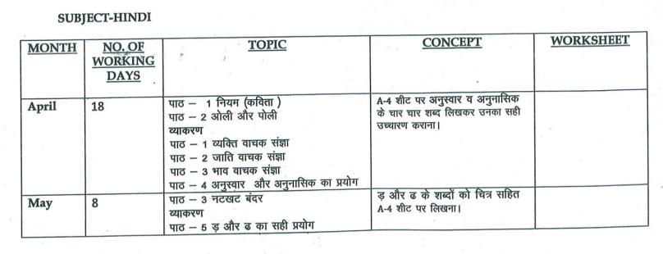
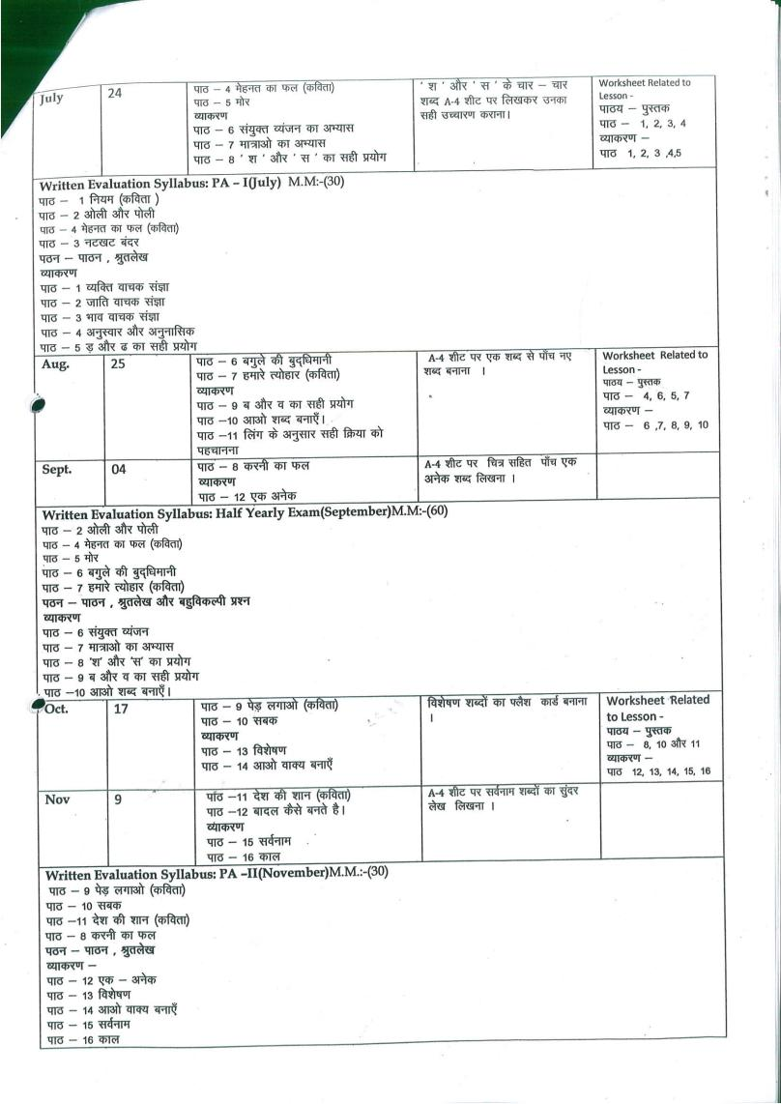

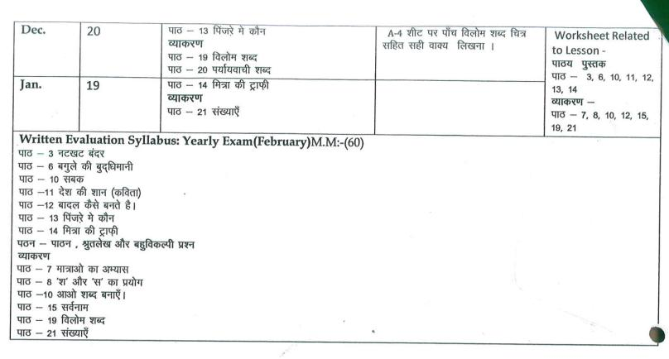
SUBJECT-MATH

MONTH | NO. OF WORKING DAYS | TOPIC | CONCEPT | ACTIVITY | WRORKSHEET
Apr. | 18 | Ch-1 Revision (Number 1 to 100)  Ch-2 Ordinal Numbers  Ch-3 Three digit Numbers | - Introduction of ordinal numbers  - Number names, face value, Place value & expanded form | - Hopscotch  - Factastic Train | Ch-2 & 3+tables 2 to 5
May | 8 | Ch-3 Three digit Numbers (continue) | - Number names , face value , place value and expanded form | - Abacus  - Hopscotch
Jul. | 24 | Ch-5 Addition  Ch-6 Subtraction | - Addition of 1 and 2 digit numbers, word problem based on addition  - Subtraction of numbers, word problem based on subtraction | - Use of Abacus for addition of numbers | Ch-5 word problem on addition  Ch-6 word problem on Subtraction  Tables 6 and 7
Written Evaluation Syllabus: PA-I(July) MM(30)
Ch-2 Ordinal Numbers
Ch-3 Three digit Numbers
Ch-5 Addition
Ch-6 Subtraction
Dodging tables 2 to 7
Aug. | 25 | Ch-4 Even and odd  Ch-7 Multiplication  Ch-8 Division | - Multiplication using repeated addition, number line & tables.  - Division using multiplication tables | - Showing division using beads and shells  - Ganit mala | Word problem worksheet on Multiplication & division
Sep. | 4 | Ch-9 Fraction  Ch-17 Patterns  Ch-11 Skip Counting | Fractions-Basic introduction and learning about patterns in nature | - Fractions through flower  - Fractions through paper folding  - Ch-11,17 to be done activity based | Worksheet on fractions Combined Wsheet on ch-11 , 17
Written Evaluation Syllabus: Half yearly Exam(September) MM(60)
Ch-4 Even and odd Ch-7 Multiplication
Ch-8 DivisionCh-9 Fraction
Ch-17 Patterns
Dodging tables 2 to 7
Oct. | 17 | Ch-13 Measurement of Weight  Ch-16 Time | - Basic units of weight  - Add and subtract weights  - To read time, days of week &months | - To make a weighing balance. | Worksheet of ch-13 & 16
Nov. | 9 | Ch-10 Money | - Introduction of Money and the Indian currency | - Paste the fake currency notes of different denominations on A4 Sheets | Worksheet of ch-10
Written Evaluation Syllabus: PA-II(November) MM(30)
Ch-10 Money Ch-11 Skip counting
Ch-13 Measurement of WeightCh-16 Time
Dec. | 20 | Ch-12 Measurement of length  Ch-15 Geometry | - Units of length, measurement of length.  - Shapes & its types. | - Using a ruler measure your hand span  - Showing solid and plain shapes in the Maths Lab | Worksheet of ch-12 & 15  Tables 8 and 9
Jan. | 19 | Ch-14 Measurement of Capacity | - Litres&Mililitres | - Unit Chart | Worksheet of ch-14
Written Evaluation Syllabus: Final Exam(February)MM(60)
Ch-12 Measurement of length
Ch-13 Measurement of Weight
Ch-14 Measurement of Capacity
Ch-15 Geometry
Ch-16 Time
Dodging tables 2 to 12

SUBJECT-EVS
MONTH | NO OF WORKING DAYS |  | TOPIC | CONCEPT | ACTIVITY | WOKSHEET
April | 18 |  | Ch 1- Body and Health  Ch 2- Inside my body | 1. Showing picture of different parts of body and their work.  2.Lab visit and show the function of internal organs | Paste any 3 internal organs on A-4 size sheet. | Ch 1 and Ch -2
May | 8 |  | Ch 3- Family and Friends | 1.Showing picture of small family and Joint family. | 1. Draw family tree.
July | 24 |  | Ch 4- House we live In  Ch 5- Food we Eat  Ch 6- Clothes we wear | 1.Showing modal of different types of houses  2. Discuss the need for eating different kind of food by showing fruit chart.  3. Showing real clothes worn in different seasons. | 1. Paste pictures of different types of houses on A4 Sheet and write their names.  2.Paste pictures of two each :-  Energy giving food.  Body building food.  Protective food on A4 Sheet. | Ch-3 and ch-4
Written Evaluation Syllabus: PA –I(July) MM(30)
Ch 1- Body and Health
Ch 2- Inside my body
Ch 3- Family and Friends
Ch 4- House we live In

Aug. |  | 25 | Ch 7-Places of worship  Ch 8- Days to Celebrate  Ch 9- People who Help us | 1.Discussions about different type of festival and their values by showing pictures  2.Discussion about our helpers . | Collect pictures of any five helpers and write their work on A4 sheet | Ch-5 and ch-6
Sep. |  | 4 | Revision |  |  | Recaptulation worksheet
Written Evaluation Syllabus: Half Yearly Exam(September) MM(60)
Ch 2- Inside my body
Ch 3- Family and Friends
Ch 5- Food we Eat
Ch 6- Clothes we wear
Ch 7-Places of worship
Ch 8- Days to Celebrate
Ch 9- People who Help us
Oct. |  | 17 | Ch 10- Neighbourhood services  Ch 11- Map of India | 1. Discussion about neighborhood service | Do the page no.72. | Ch-10 and ch-11
Nov. |  | 9 | Ch 12- Plants and Animals around us  Ch 13- Weather and Seasons | 1.Showing real thing that we get from plants and animals. | 1. Make a list of any 5 things that we get from animals. Paste their pictures and write the name of the animals in A4 Sheet.  2. 1. Paste picture of different seasons on A- 4 sheet | Recaptulation worksheet
Written Evaluation Syllabus: PA II(November) MM(30)
Ch 4- House we live In
Ch 10- Neighbourhood services
Ch 11- Map of India
Ch 12- Plants and Animals around us
Ch 13- Weather and Seasons
Dec. |  | 20 | Ch 14- Earth and Its neighbours  Ch 15- Save the Earth  Ch 16- Means of Communication | 1. Showing Globe  2.Discussion about how we save the Earth | 1.Paste the picture of different means of communication in note book. | Ch-14,15 and ch-16
Jan. |  | 19 | Ch 17 – Transport and Safety  Ch 18 – Games we play | 1.Discussion about safety Habits by showing pictures. | 1. Collect pictures of outside and inside game and paste them on A4 Sheet. | Ch-17 and ch-18
Feb. |  | 6 | Revision |  |  | Recaptulation work sheet
Written Evaluation Syllabus: Yearly Exam(February) MM(60)
Ch 7-Places of worship
Ch 10- Neighbourhood services
Ch 14- Earth and Its neighbours
Ch 15- Save the Earth
Ch 16- Means of Communication
Ch 17 – Transport and Safety
Ch 18 – Games we play

SUBJECT-COMPUTER
MONTH | NO. OF WORKING DAYS | CONTENT | ACTIVITY | PRACTICAL | WORKSHEET
April | 18 | Ch – 1 : Know about computer  Ch – 7 : Knowing windows | * Draw computer and write its qualities in notebook | *Paint | Ch-1, 7  Ch - 9
May | 8 | Ch – 9 : Draw and Paint | *Draw different tools of paint window in notebook.
July | 24 | Ch – 3 : Knowing Computer Parts(Reading) |  | * Tux Paint
Written Evaluation Syllabus: PA –I(July) MM(20)
Ch – 1 : Know about computer
Ch – 7 : Knowing windows
Ch – 9 : Draw and Paint
Practical: Paint
Aug. | 25 | Ch – 3 : Knowing Computer Parts(Exercise)  Ch – 4 : How does computer work  Ch – 10 : Tux Paint | * Paste different parts of computer in your notebook. | * Tux Paint | Ch-3 , 4  Ch- 10
Sep. | 4 | Revision
Written Evaluation Syllabus: Half Yearly Exam(September) MM(30)
Ch – 3 : Knowing Computer Parts
Ch – 4 : How does computer work
Ch – 10 : Tux Paint
Practical: Tux Paint
Oct. | 17 | Ch – 5 : Exploring the keyboard  Ch – 6 : Using the mouse(Reading) | * Draw different types of keys in notebook. | *Tux Paint | Ch-5  Ch- 6
Nov. | 9 | Ch – 6 : Using the mouse(Exercise) | * Draw and label different parts  of mouse.
Written Evaluation Syllabus: PA II(November) MM(20)
Ch – 5 : Exploring the keyboard
Ch – 6 : Using the mouse
Practical: Tux Paint
Dec. | 20 | Ch – 2 : Uses of Computer  Ch – 11 : Type using Word Pad | * Paste different types of computerized bills or tickets in your notebook.  *Draw Font Family box of wordpad in notebook. | *Wordpad | Ch-2,11  Ch-8
Jan. | 19 | Ch – 8 : Storing your data. | *Draw different types of disks in your notebook.
Feb. | 6 | Revision
Written Evaluation Syllabus: Yearly Exam(February)MM:-30
Ch – 2 : Uses of Computer
Ch – 11 : Type using Word Pad
Ch – 8 : Storing your data.
Practical:Wordpad

SUBJECT: G.K.
MONTH | NO. OF WORKING DAYS | CONTENT
April | 18 | Page no. 3 to Page no. 11
May | 8 | Page no. 12 to Page no. 16
July | 24 | Page no. 17 to Page no. 21  Revision
Written Evaluation Syllabus: PA-I(July) M.M.-20
Page no. 3 to Page no. 15
Aug. | 25 | Page no 22 to Page no 28  Page no 53 and Page no 55
Sept. | 4 | Revision
Written Evaluation Syllabus :Half Yearly Exam (September) M.M.- 30
Page no . 16 to Page no. 28
Page no. 53 and Page no. 55
Oct | 17 | Page no.29 to Page no 39
Nov. | 9 | Revision
Written Evaluation Syllabus: PA-II (November) M.M.- 20
Page no. 29 to Page no. 39
Dec. | 20 | Page no. 40 to Page no. 49
Jan. | 19 | Page no. 50 to Page no. 52, Page no. 54 and Page no. 56
Feb. | 6 | Revision
Written Evaluation Syllabus: Yearly Exam(February) M.M.-30
Page no. 40 to Page no. 52
Page no. 54 and Page no. 56

SUBJECT-DRAWING & ART/CRAFT
MONTH | NO. OF WORKING DAYS | PAGES OF ART BOOK | ACTIVITY
April | 18 | 3-4,21,27,28 | Birds (Thumb Impression)  Flower And Sun  Crab
May | 8 | 5-6, 29, 30 | Tree (Bindi Pasting  Flower Pot (Wool String Pasting)
July | 24 | 7, 8, 9, 22, 32, 33 | Sheep Paper Impression Mushroom, Pencil Shaving, Button , Rubber Band Pasting, Rangoli Design
Aug. | 25 | 10, 11, 12, 23,31 ,34 | Teachers Day Card  Hen Coop Foam Pasting
Sep. | 4 | Revision
Written Evaluation Syllabus: Half-Yearly Exam(September)
Page no.3 to Page no. 12
Page no. 27 to Page no. 34
Oct. | 17 | 13, 14, 35, 36 | Bunny icecream stick 35  Nest Broom, grass pasting 36
Nov. | 9 | 15-16, 17, 37, 40 | Butterfly paper folding 37  Steam engine – foil and jute string pasting 40
Dec. | 20 | 18, 19, 20, 41, 43 | Horse – stick pasting and fencing (BARN) 43
Jan. | 19 | 21, 22, 23 | Elephant (Model)
Feb. | 6 | Revision
Written Evaluation Syllabus: Yearly Exam(February)
Page no.13 to Page no. 20
Page no. 24 to Page no.26
Page no. 35 to Page no. 43

SUBJECT-DANCE
Month | Number of Working Days | Topic
April | 18 | Foot, Shoulders, Hands, Neck, Waist movements
May | 8 | Foot, Shoulders, Hands, Neck, Waist movements
July | 24 | Aerobics and body stretching exercises  Body balancing movements
Aug. | 25 | Aerobics and body stretching exercises  Body balancing movements (Janmastmi Celebration)
Sep. | 4 | Free style dancing (Dussehra celebration)
Oct. | 17 | Free style dancing (Dussehra celebration)
Nov. | 9 | Western Dance (Christmas Celebration)
Dec. | 20 | Western Dance (Christmas Celebration)
Jan. | 19 | Patriotic dance (Republic day celebration)
Feb. | 6 | Patriotic dance (Republic day celebration)
- Presentation of houses activity

